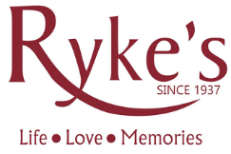
Congratulations on your engagement, and thank you for your interest in Ryke's Bakery! We offer a variety of options for couples to celebrate their big day: everything from tiered cakes, to centerpiece cakes, dessert buffets, doughnut bars, cupcakes, and more!

We now offer delivery one hour radius from our Muskegon location. Two tier cakes and smaller can be picked up from our satellite locations.

Our full consultations last about an hour, during which we will design your wedding cake inside and out and enjoy a complimentary tasting of our classic flavors. To reserve your date and place the order, we ask for a 20% deposit. At the end of the meeting, you will be able to cross your wedding desserts off your list!
~ If you are unable to come in, we offer a to-go tasting for $10.00. You can pick them up from any of our three locations.

To start the process of building your dream wedding cake, please fill out the form below.

General Information
Name (Primary Contact):

Spouse’s Name:

Primary Contact Number: Spouse’s Number:

Billing Address:

City: State: Zip:

Email Address:

Date of Event: Estimated Guest Count:

Event Location:

Indoor or Outdoor? Is there Refrigeration available?

Pick up___________ or Delivery_____________

If Yes to pick up:

Muskegon Holland: Grand Haven: __________

Budget: ____________________________

Cake design
Select a design or speak to a wedding specialist for customized cakes
#1 – Smooth #2 – Fluted #3 – Semi Naked

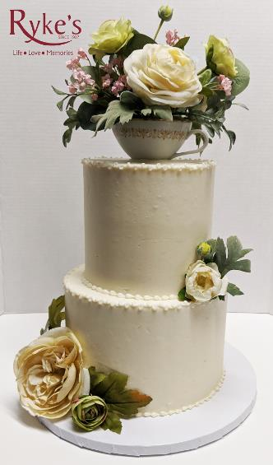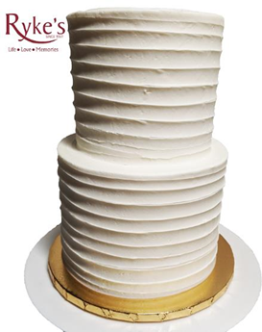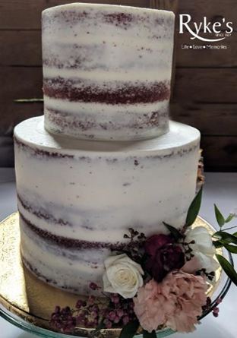

(Flowers Not Included) (Flowers Not Included)

#4 – Simple Birch #5 – Realistic Birch #6 - Ombre

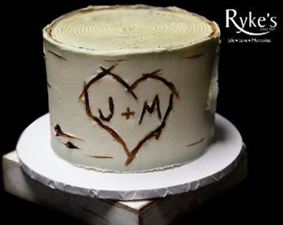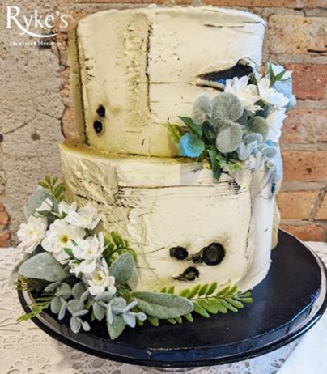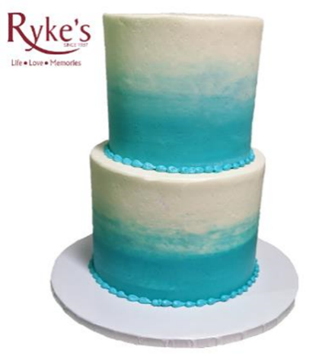

(Flowers Not Included)

#7 – Scrolls #8 – Rosettes #9 – Ruffle

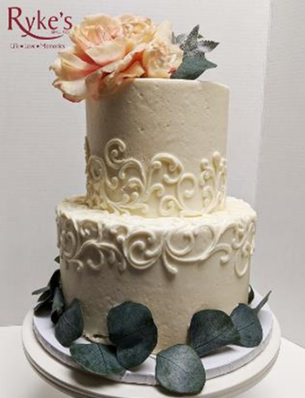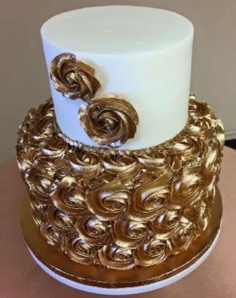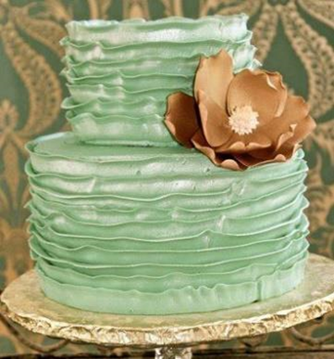

Pricing:
Prices At:

Design #1 - Smooth: Single Tier: $100 2 Tier: $263

Design #2 – Fluted: Single Tier: $100 2 Tier: $263

Design #3 – Semi Naked: Single Tier: $95 2 Tier: $250

Design #4 – Simple Birch: Single Tier: $120 2 Tier: $313

Design #5 – Realistic Birch: Single Tier: $140 2 Tier: $363

Design #6 – Ombre: Single Tier: $110 2 Tier: $289

Design #7 – Scroll: Single Tier: $105 2 Tier: $275

Design #8 – Rosettes: Single Tier: $135 2 Tier: $350

Design #9 – Ruffle: Single Tier: $135 2 Tier: $350

Additional Desserts

Sheet Cakes:
Cake Size: | Servings: | Starting Price:
¼ Sheet Cake | 20 | $36.00
½ Sheet Cake | 40 | $55.00
Full Sheet Cake | 80 | $95.00

Cupcakes:
Cupcake Type: | Standard Size: (per Cupcake) | Mini Size: (per Mini Cupcake)
Classic Cupcakes | $1.50 | $1.00
Gourmet Cupcakes | $2.75 | $1.75
Standard cupcake liners are silver, ask about other color options if needed.

Dessert Bars:
Type: | Flavors: | Price: (per Bar)
Brownies  (Ordered by the Dozen) | Walnut, Peanut Butter, and Cream Cheese | $2.00
Bars  (Ordered by the Dozen) | Lemon and Raspberry | $2.00
Cheesecake  (Ordered by the Dozen) | Blueberry, Raspberry, Cherry, and Strawberry | $2.00
Bars  (Ordered by the Dozen) | White Chocolate Salted Caramel | $2.50
Please note all bars and bites must be ordered by the dozen

Cheesecake:
Type: | Flavors: (Available in All Sizes) | Price: (per Cheesecake)
3-inch Personal | Chocolate Chip, Turtle, Peanut Butter Cup | $3.50
Whole Cheesecakes (9”) | Fruit Toppings Available: | $40.00

Flourless:
Type: | Flavors: (Available in All Sizes) | Price:
3-inch Personal Cakes | Plain, Chocolate Raspberry, | $6.00
We are not a certified gluten-free bakery. This item is produced in a facility that has gluten products

Cookies:
Cookie Flavor: | Type: | Price:
Sugar Cookies | Buttercream, Sugar Dipped or Sprinkles | $1.35 Each
Homestyle Cookies | Chocolate Chip, Peanut Butter, and Oatmeal Raisin | $8.00 Dozen

Donuts:
Donut Type: | Flavors: | Price:
Classic Donut | Cake, Sour Cream, & Yeast Raised | $1.50
Gourmet Donut | Long Johns, Cinnamon Roll, Bismarck, & More! | $1.95

Shooters:
Variety | Flavors | Fillings | Price
Classic | Vanilla, Marble, Chocolate | Bavarian, Chocolate Bavarian, Raspberry, Strawberry, Lemon, Butter whip, Butter Cream, Chocolate Butter cream | $3.00 each
Gourmet | Red Velvet, Orange Cream, Cherry Chip, Lemon, Carrot, Strawberry  Some other gourmet batters may be available seasonally | Gourmet varieties of Bavarian (Peanut Butter, Raspberry, Strawberry, etc.)  Gourmet varieties of whip (Mint, Cookies n’ Cream, etc.) | $3.50 each
We do ask that these are ordered in a 2 dozen minimum.

Chocolate Covered Strawberries
Initial Dip | Drizzle | Price
Chocolate, White Chocolate, Tinted Chocolate (for extra fee) | Chocolate, White Chocolate, Tinted Chocolate (for extra fee) | $2.50 each
Special decoration can be quoted upon request. In season only

Additional Information

Contract
Cancellation:
- A minimum of $50 of the deposit is non-refundable under any circumstances. This $50 covers consulting and administrative fees associated with the order.
- All but 20% of the cost of the cake will be refunded if 1) Cancellation occurs within 120 days of the event or 2) We have turned other orders away for your date due to being fulling booked.
- Orders cancelled within 7 days of the event will NOT be refunded and payment will be due in full as product has been ordered and cake has moved into production planning.
Renting or Borrowing Equipment:
- It is the customer's responsibility to return any equipment rented
- All equipment must be returned by the Wednesday (or 4 days following) follow the event. - If not returned, the $50 equipment deposit will be forfeited as we will have to retrieve the equipment.
- Customer will be billed to replace missing or damaged equipment. Billing will include wholesale cost of
Equipment, shipping charges and any rental costs incurred due to equipment needed for upcoming events. The $50 deposit will be applied to the charges and then the remaining charges will be invoiced
Disclaimers:
- We reserve the right to cancel the cake if full payment is not received within 7 days of the event -- Cakes will not be baked unless fully paid for.
- Esther & Sara's Bakery, LLC - dba Ryke's is not liable for inedible products used to decorate the cake.
- Liability is limited to the cost of the cake only, not punitive damages.
- Esther & Sara's Bakery LLC, dba Ryke's reserves the right to arbitration.
- If customer insists on structural or design elements that Ryke's deems unsafe or unstable, Ryke's is not liable for potential damages.
- When cakes are set up outdoors, Ryke's is not liable for "acts of God"(i.e. bugs, animals, extreme heat or
humidity, etc.).
- Ryke's liability ends at set up. If damage occurs due to weather conditions (i.e. extreme heat or humidity) or
negligence on the part of guests, the venue or other vendors, Ryke's will repair, but customer accepts
responsibility for cost of the repairs and the travel associated with those repairs.
- If wedding cake is picked up at the bakery, liability ends when the cake leaves the front door of the bakery. The customer has been given the option for set up and delivery and declined. Ryke's will repair and even replace product, but customer accepts responsibility for cost of the repairs and the travel associated with those repairs.
- Allergen Statement - Our products contain flour, wheat, cocoa, nuts, yellow 40, Red 5.
- In order to protect our brand, all dessert items served at your event must be purchased from Ryke's bakery unless agreed upon by both parties in writing.
Ryke's Guarantee:
- No matter what unforeseen circumstances may occur, Ryke's guarantees that a cake will be delivered to your event. If the circumstances resulted from our negligence these will be provided at no charge. Otherwise, customer will be responsible for any related cost. Our reputation is based on exceeding your expectations and following through with promises made. We will do everything in our power to ensure that you and your guests have cake and/or desserts.

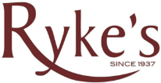

I have read and agree to these terms on the above contract.

Signature: Date:

Print Name:

